**The Ebony Marauders**

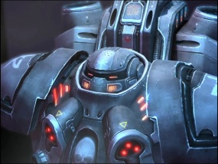

* **Game: Shadow of the Colossus**
* **Assignment: Slenderman**
* Myles
* Alex
* Matt

**Porygon Pals**



* **Game: Call of Duty: Blops2**
* **Assignment: Portal**
* Bryan
* James
* Annie
* Gavin

**Panda Power**



* **Game: Amnesia**
* **Assignment: Blops2**
* Michael
* Danny
* Dung

**Suicidal Double Rainbow (All the way)**

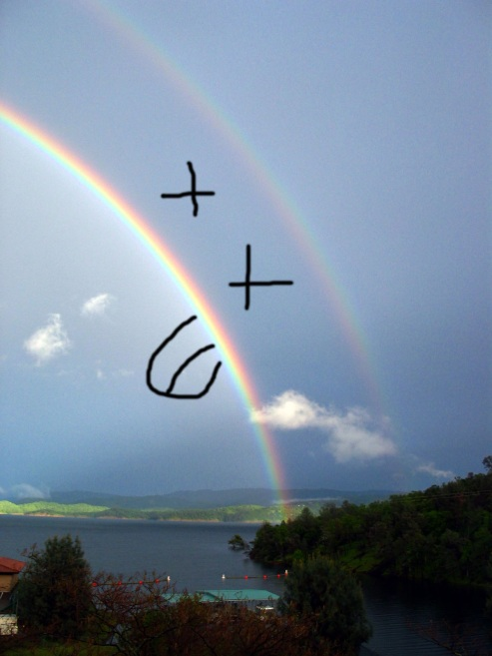

* **Game: Portal**
* **Assignment: Amnesia**
* Jovy
* Richard
* Alex

**Team Jimmay**



* **Game: Slenderman**
* **Assignment: Shadow of the Colossus**
* Jimmy
* Will
* Nicolette